MCTS

This document provides details for installing docker on user machine. It has details of downloads and installation steps required to facilitate the docker training program.

Docker training

Prerequisites for Docker Training

**Contents**

Prerequisites 2

Installations 3

VM Manager installation Steps 3

OS Installation using VDI: 3

Other Details 10

Lab activities: 10

# Prerequisites

* Download and install “Virtual Box” by using below link

<https://download.virtualbox.org/virtualbox/6.1.8/VirtualBox-6.1.8-137981-Win.exe>

* Download the CentOS VDI file using the link given below:

<https://www.osboxes.org/centos/#centos-1908-vbox>

Download 7-1908

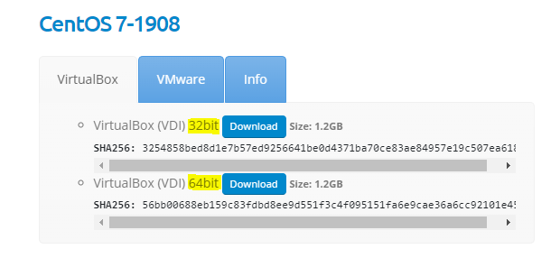

Info tab you can see passwords which we require later:

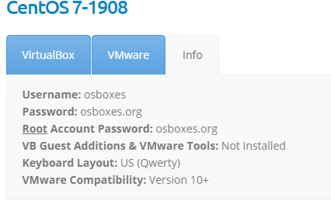

# Installations

## VM Manager installation Steps

* Once you downloaded “Virtual Box”, just run the application as an Administrator and proceed the installation steps without modifying anything until get this below page.

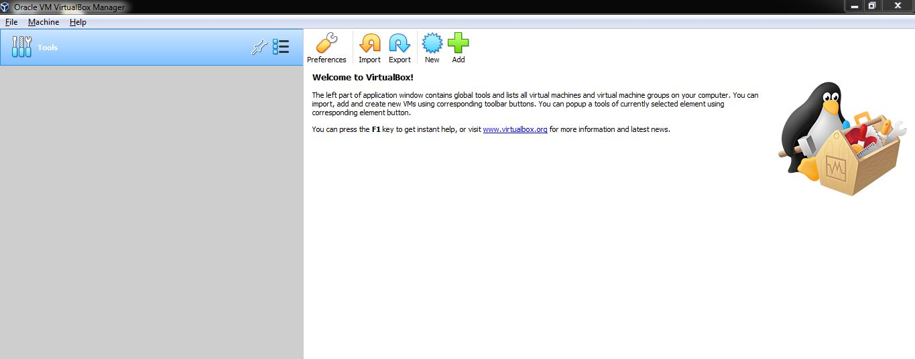

## OS Installation using VDI:

Once file is downloaded. Open VM Box Manager:

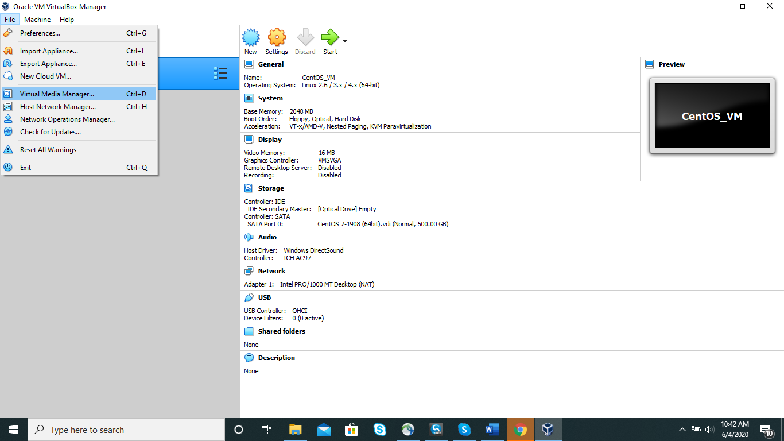

Click on Add

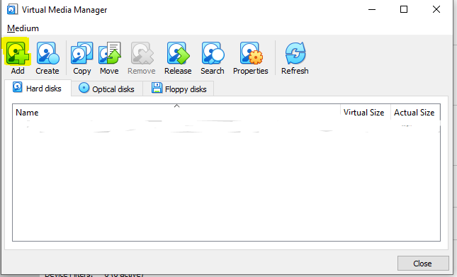

Provide the path of VDI file which we downloaded earlier. Close once VDI is added.

Now again in VM Manager click on New icon

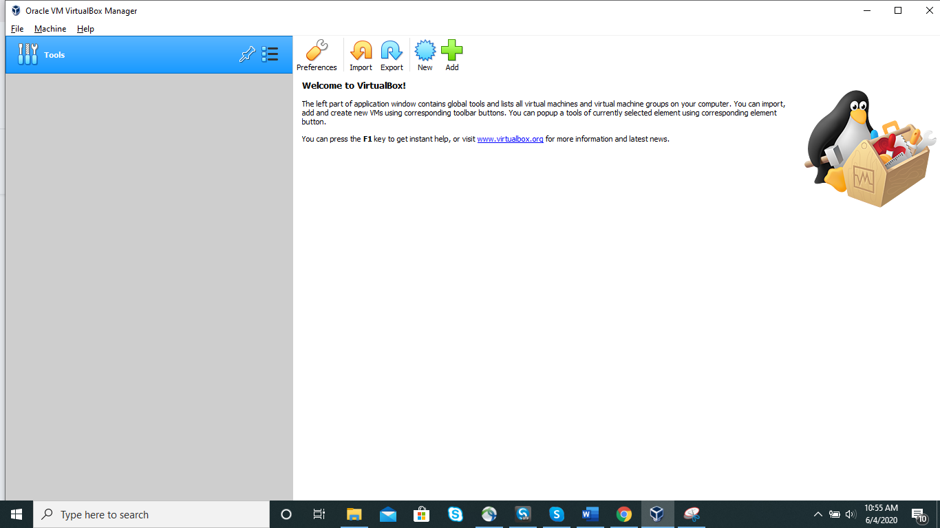

Provide Name and select below mentioned options:

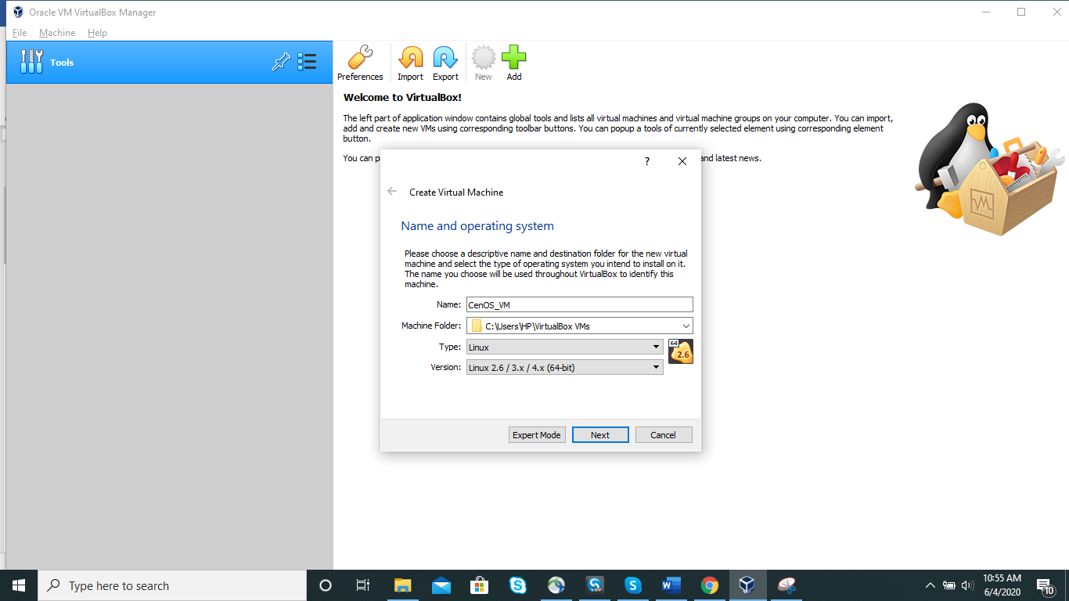

Keep size as 2048 (min. required is 1024)

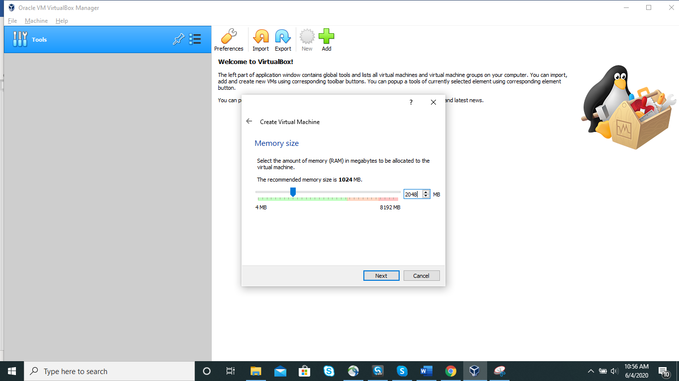

Select last option to select hard disk file. Click on Create.

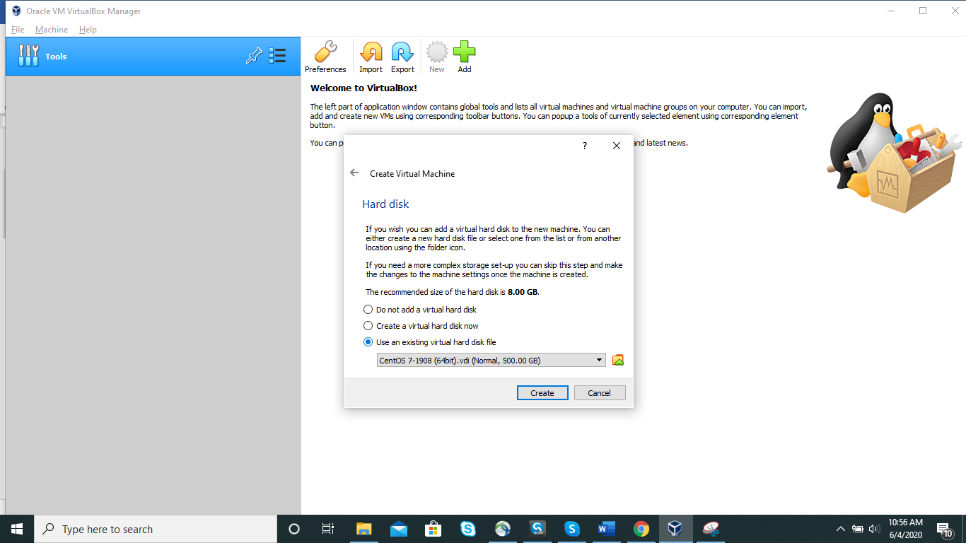

VM will get created. Now Click on Start Button

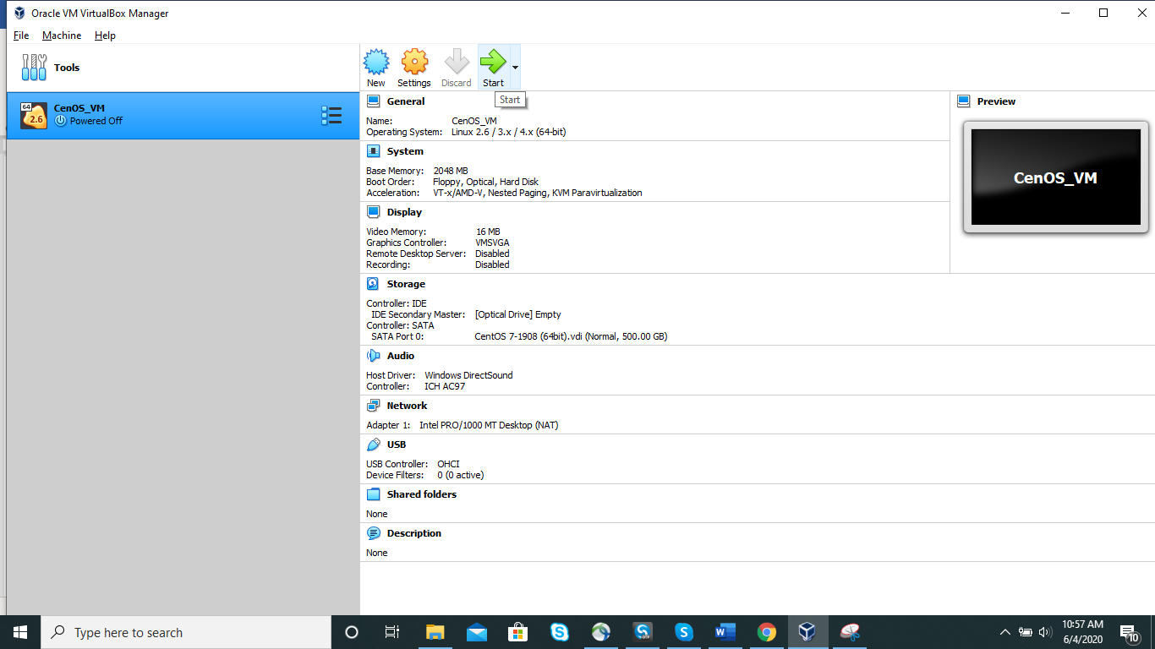

Select first Option and enter. The next screen will take time.

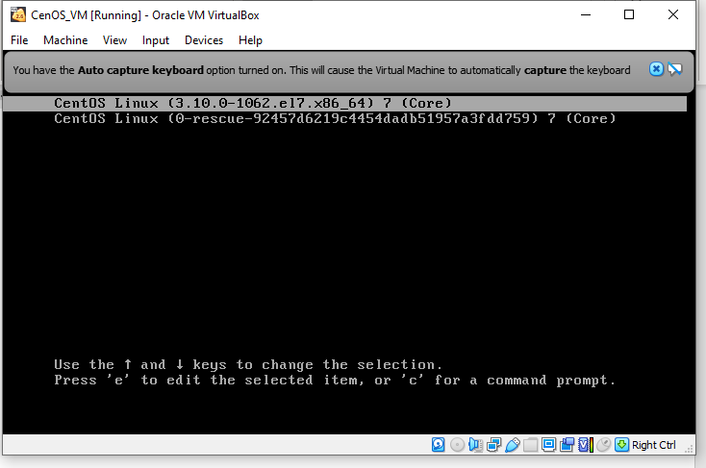

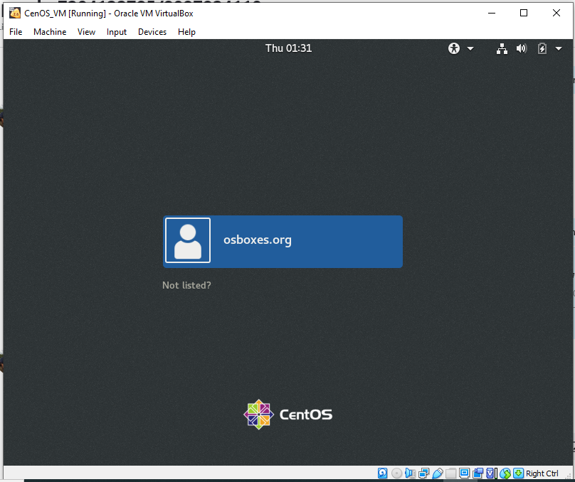

Provide the password. (currently its osboxes.org for above user)

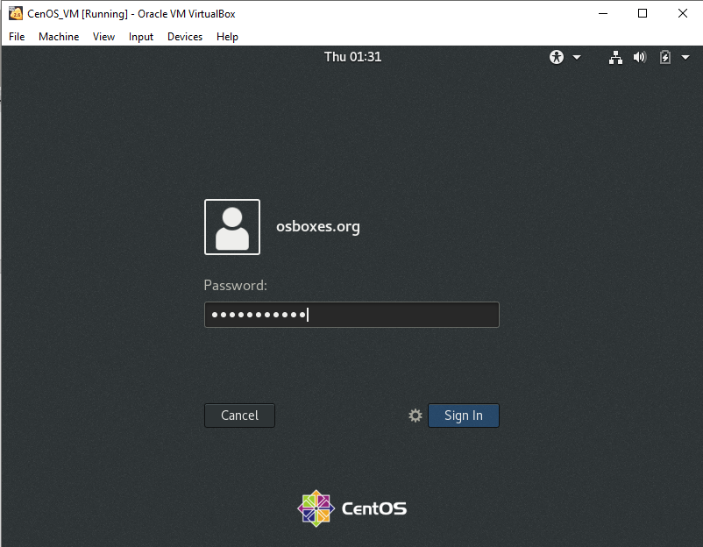

Set the language preference:

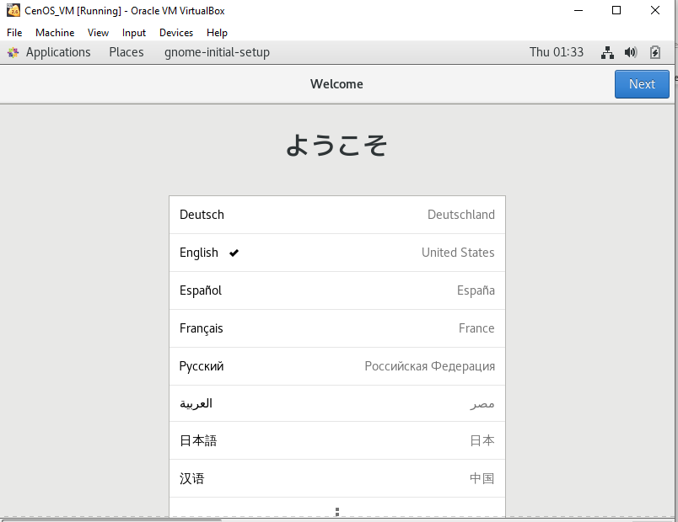

OS is set:

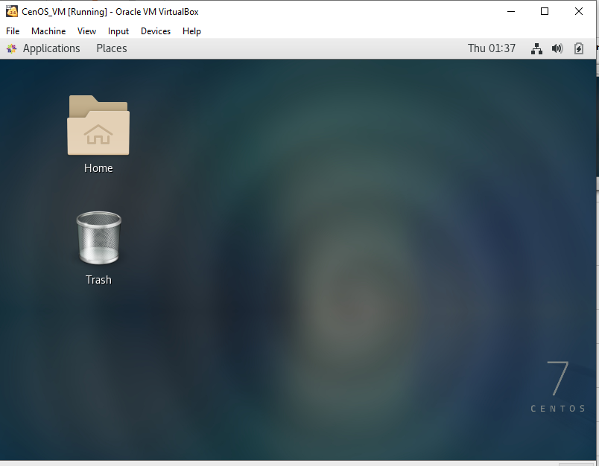

To open terminal use below option:

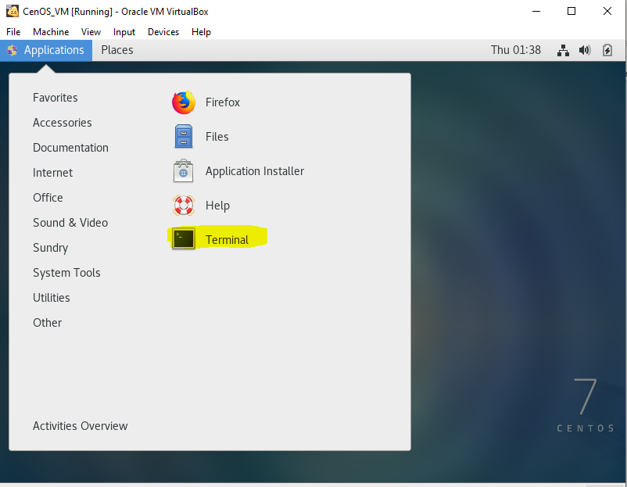

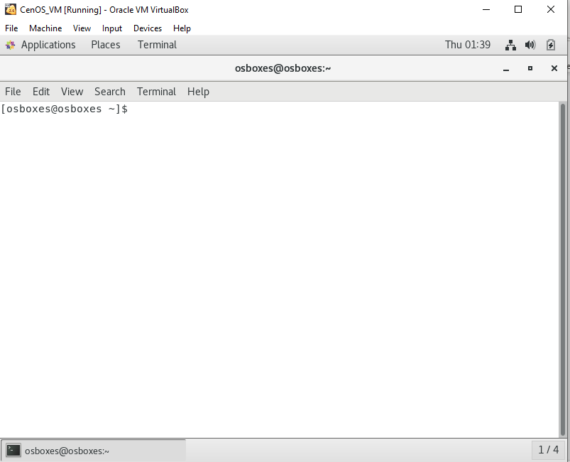

# Other Details

## Lab activities:

https://docs.docker.com/get-started/part2/

https://github.com/docker/labs/blob/master/beginner/chapters/alpine.md